Exp. No: 1
Date:

Transformation between Cartesian, Cylindrical and spherical coordinate system

Aim:
To write program for Transformation between Cartesian, Cylindrical and spherical coordinate system using SCILAB.

Software required:
•SCILAB version 6.0.1

Program:
Test case (i) Transformation of Cartesian coordinate points in to Cylindrical and spherical coordinate system

clc;
clear;

x = 3;
y = 4;
z = -6;
r = sqrt(x^2 + y^2);
phi = atan(y, x) * 180 / %pi;
disp("Cartesian to Cylindrical Coordinates (r, phi, z):");
disp([r, phi, z]);
R = sqrt(x^2 + y^2 + z^2);
theta = acos(z / R) * 180 / %pi;
phi = atan(y, x) * 180 / %pi;
disp("Cartesian to Spherical Coordinates (R, theta, phi):");
disp([R, theta, phi]);

Given values:
x = 3
y = 4
z = -6

Output :
Cartesian to Cylindrical Coordinates (r, phi, z):
5. , 53.130102 , -6.

Cartesian to Spherical Coordinates (R, theta, phi):

7.8102497 , 140.1944289 , 53.130102
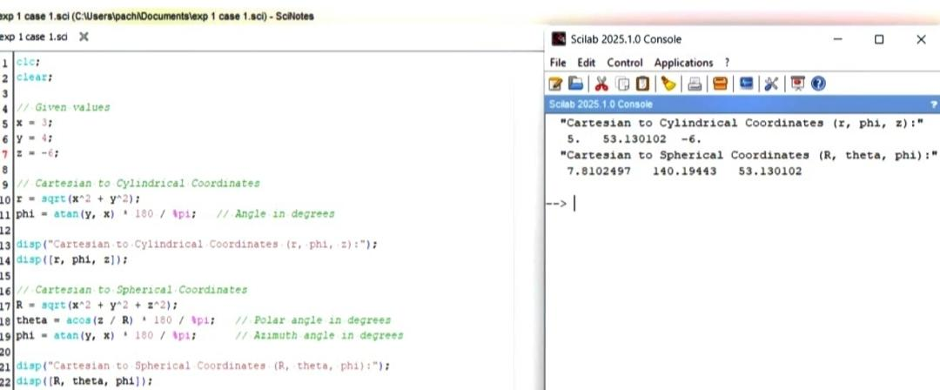

Calculation:

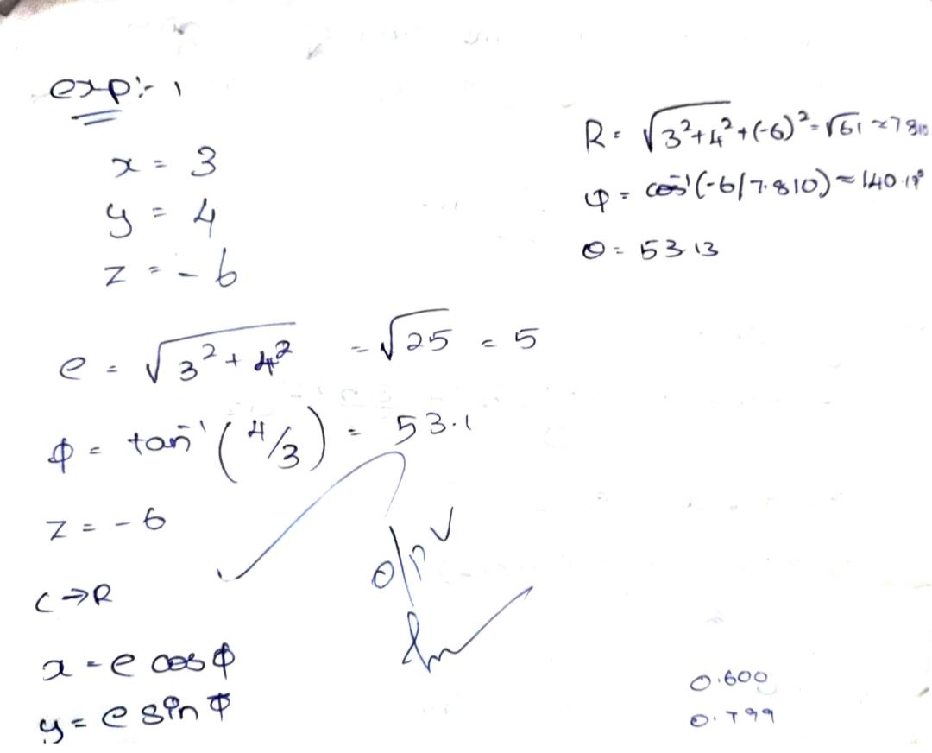

Test case (ii) Transformation of Cylindrical coordinate points into Cartesian and spherical coordinate system

clc;
clear;
r = 3;
phi = 60;
z = -5;
x = r * cosd(phi);
y = r * sind(phi);
disp("Cylindrical to Cartesian coordinate system P(x,y,z) =");
disp([x y z]);
R = sqrt(x^2 + y^2 + z^2);
theta = acosd(z / R);
disp("Cylindrical to Spherical coordinate system S(R,phi,theta) =");
disp([R phi theta]);

Outcome:
Cylindrical to Cartesian coordinate system P(x,y,z) =
1.5 , 2.5980762 , -5.
Cylindrical to Spherical coordinate system S(R,phi,theta) =
5.8309519 , 60. , 149.03624

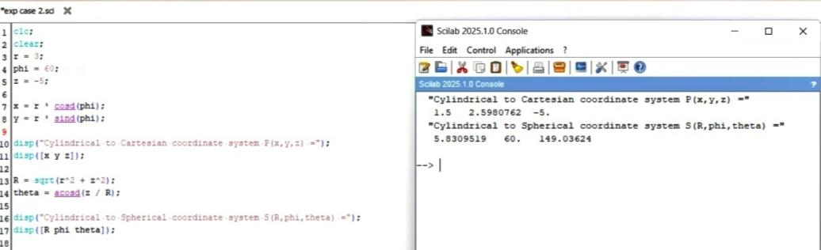

Calculation:

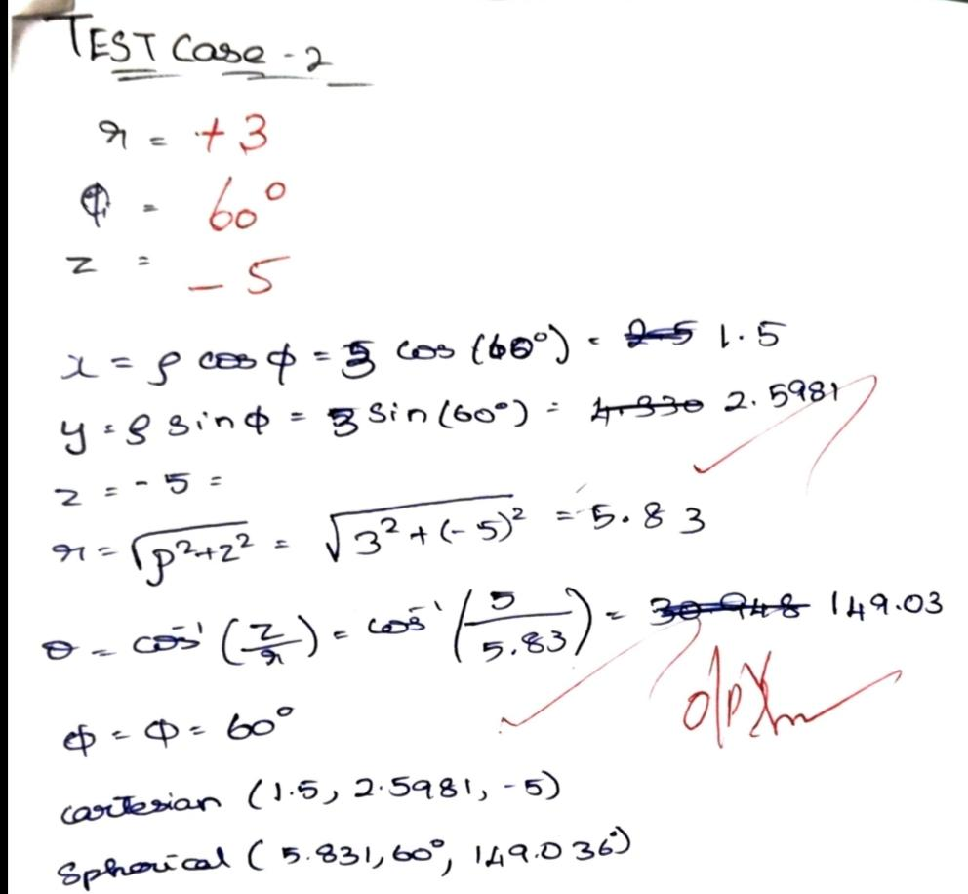

Test case (iii) Transformation of spherical coordinate points into Cylindrical and Cartesian coordinate system

clc;
clear;
r = 5;
phi = 70;
theta = 60;
x = r * sind(theta) * cosd(phi);
y = r * sind(theta) * sind(phi);
z = r * cosd(theta);
disp("Spherical to Cartesian Coordinates (x, y, z):");
disp([x y z]);
rho = r * sind(theta);
phi_cyl = phi;
z_cyl = r * cosd(theta);
disp("Spherical to Cylindrical Coordinates (rho, phi, z):");
disp([rho phi_cyl z_cyl]);

Output
Spherical to Cartesian Coordinates (x, y, z):
1.4809907 4.0689884 2.5
Spherical to Cylindrical Coordinates (rho, phi, z):
4.3301270 70. 2.5
